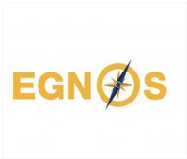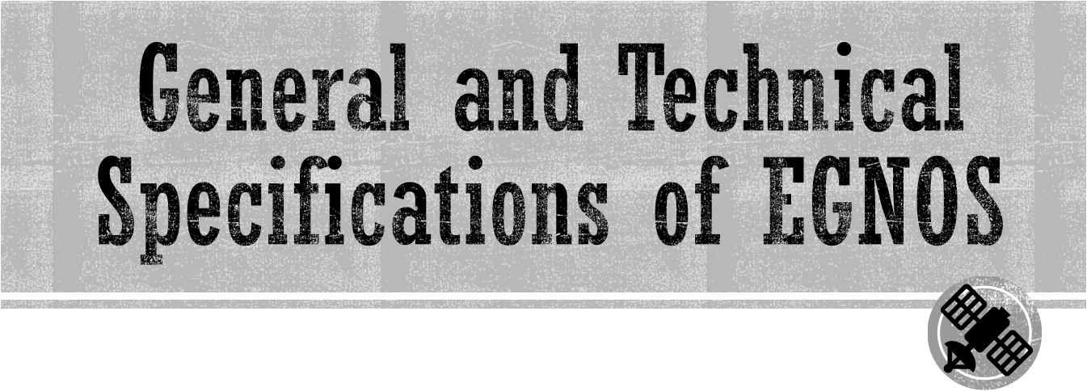

Prepared by:

Alp Eren Filiz

10190620

Mehmed Emre Dağlı 10190621

Lusin Demirci 10190623

Ali Berat Bozkurt 10190625

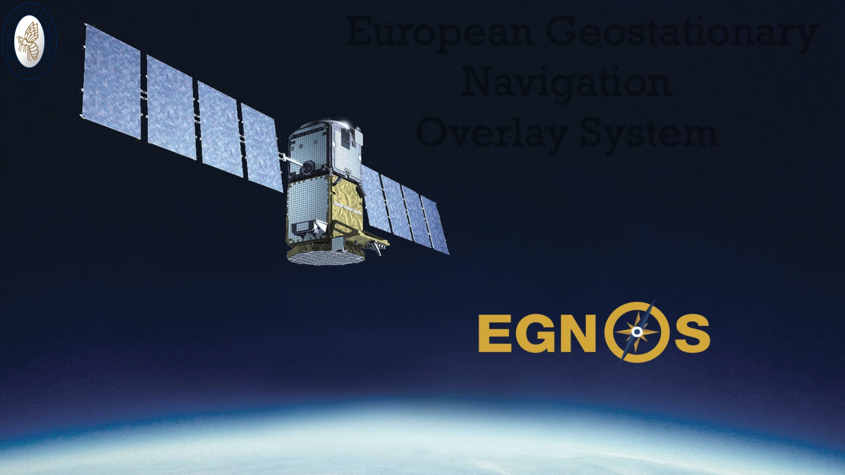

European Geostationary

Navigation

Overlay System



Navigation with satellite systems has been valuable technology in especially commercial aviation sector in terms of security and activity at the beginnings of 2000’s as well as many other industries. Also, neccessity of supportive systems has revealed because of the some inherent restrictions caused by the natural structures of Global Navigation Satellite systems.

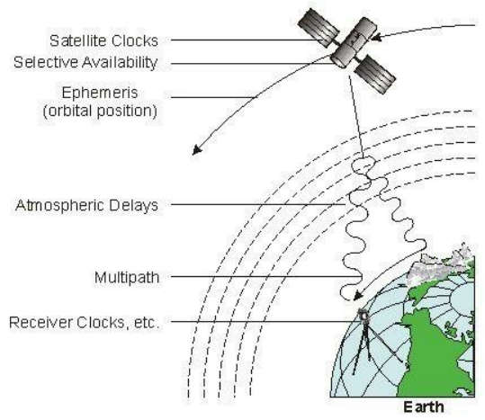

It can be listed that restrictions caused by the natural structures of Global Navigation Satellite systems as mainly;

• Satellite clock offset

• Ephemeris bias

• Ionospheric delay

• Tropospheric delay

• Receiver errors

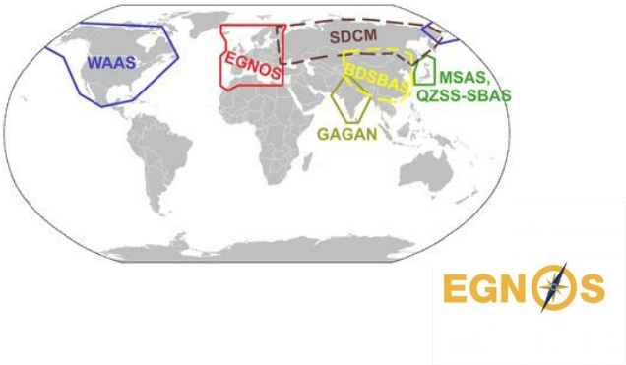

USA Europe Russia Japan India China

WAAS ( Augmented to GPS) EGNOS (GPS, GALILEO,GLONASS) SDCM (GLONASS)

MSAS GAGAN SNAS



The European Geostationary Navigation Overlay Service (EGNOS) is Europe's regional satellite-based augmentation system (SBAS) that is used to improve the performance of global navigation satellite systems GPS, GALİLEO and GLONASS.

Funding of the project has already been allocated by the European Commission through the European Neighbourhood Instrument (UNI) for infrastructure and technology development.

EGNOS is the first project of the European Union about Navigation Satellite systems and it can be say that it is the first main part of GALILEO system.



Project which is the collective venture of ESA (European Space Agency), European Commission and Eurocontrol has started in 1998.

The system started its initial operations in July 2005, with accuracy better than two metres and availability above 99%. As of July 2005, EGNOS has been broadcasting a continuous signal, and at the end of July 2005 the system was used to track cyclists in the Tour de France road race.

In 2009, the European Commission announced it had signed a contract with the company European Satellite Services Provider to run EGNOS. The official start of operations was announced by the European Commission on 1 October 2009.



▪• The system was certified for use in safety of life applications in March 2011.

▪• An EGNOS Data Access Service became available in July 2012.

▪• Also, to extend EGNOS coverage to the Southern Africa region is being done

under a project called ESESA - EGNOS Service Extension to South Africa.

▪• Cost of the project is specified as €1,1 billion.



To provide the plane’s safe flights and safe transition through especially straits and narrow canals for ships by increasing the service quality of the GPS ,GLONASS and GALILEO systems.

To provide high accuracy location determination for all users by broadcast corrections obtained from phase measurements.

To collect the availibility, continuity, accurate, integrity and ease of use specialities which are play crucial role for a navigation satellite system together.

Today, EGNOS is benefiting numerous market segments, including aviation, road, rail, maritime, surveying/mapping, location-based services and agriculture.

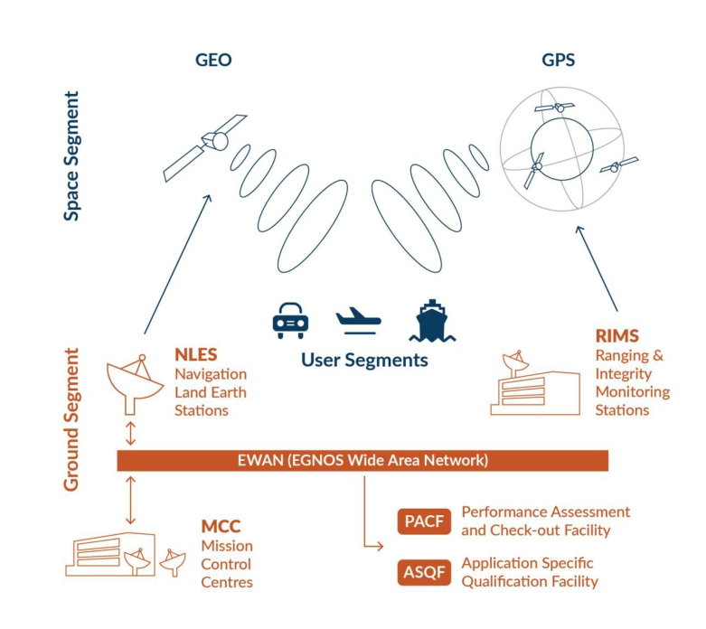

▪The EGNOS system consists of four components: space segment, ground and

support segment, and user segment.

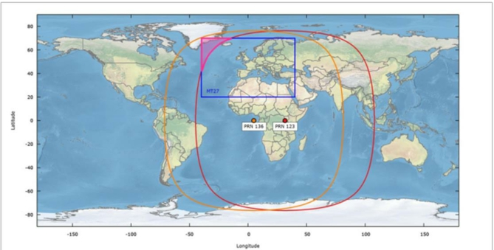

▪Four geostationary satellites (GEO) make up the EGNOS space segment, which broadcasts corrections and integrity information for GPS satellites in the L1 frequency band (1575,42 MHz).

These geostationary satellites are:

✓Inmarsat 3F2 AOR-E | PRN Number 120 | Orbital Slot 15.5 W

✓Astra SES-5 | PRN Number 136 | Orbital Slot 5 E

✓Inmarsat 4F2 EMEA | PRN Number 126 | Orbital Slot 64 E

✓Astra-5B | PRN Number 123 | Orbital Slot 31.5 E

▪

The INMARSAT 3F2 AOR-E (PRN 120)

was deactivated on January 1, 2019.



▪Inmarsat's Third Generation satellites carry a navigation payload that is used by

EGNOS.

▪ In September 1996, the first Inmarsat-3 (F2 AOR-E) satellite with an EGNOS transponder was launched (PRN 120).

▪The base spacecraft was produced by Lockheed Martin Astro Space in the United States, and the communications payload was created by Matra Marconi Space in Europe. Inmarsat-3 was the first satellite launched by the Proton launch vehicle.

▪ The GEO satellite INMARSAT 3F2 (PRN120) joined the EGNOS TEST Platform on August 30, 2018, broadcasting the TEST SIS.

▪It stopped broadcasting EGNOS SIS on January 1, 2019, and was completely

withdrawn from the EGNOS system.

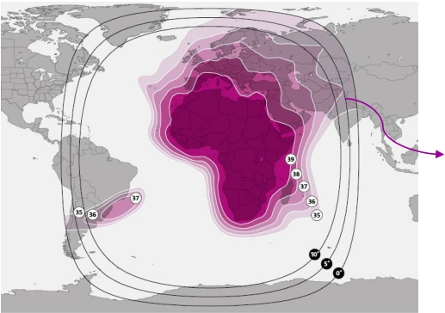

▪Astra SES-5 is a commercial geostationary communication satellite operated by

SES.

▪ It was put into orbit at 5º East on July 9, 2012. The launch was carried out by a

Proton-M/Briz-M rocket from Kazakhstan's Baikonur air base.

▪It is based on the LS-1300 satellite bus and was built by Space Systems/Loral. The satellite has 36 Ku-band (33-36MHz) transponders and 24 C band (36MHz) transponders.

▪ The goal of this satellite is to increase the capability of DTH (Direct to Home) and

EGNOS services.

SES S.A. is a Luxembourg-based satellite and

terrestrial telecommunications network provider that provides video and data access to broadcasters, content and internet service providers, mobile and fixed network operators, governments, and organizations throughout the world.

coverage area

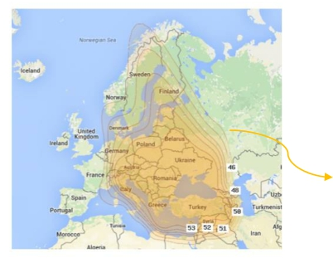

▪The Astra-5B satellite officially came into service in June 2014 at orbital position

31.5º East.

▪The Astra 5B was launched into space on 22 March 2014. The launch was made with

an Ariane 5 rocket from the Kourou air base in French Guiana.

▪There are 40 Ku-band transponders (equal to 36MHz) and 6 Ka-band transponders

on the satellite.

▪In addition this new transponder will support the next EGNOS generation (EGNOS V3) that will provide dual-frequency signals on both bands L1 and L5 and augment both GPS and Galileo.

▪As seen in the illustration, the High Power can be found throughout the

westernmost portion of Europe.

coverage area



▪The EGNOS Ground Segment comprises a network of Ranging Integrity Monitoring Stations (RIMS), two Mission Control Centres (MCC), two Navigation Land Earth Stations (NLES) per GEO satellite, and the EGNOS Wide Area Network (EWAN) which provides the communication network for all the components of the ground segment.

▪Two additional facilities are also deployed as part of the ground segment to support system operations and service provision, namely the Performance Assessment and Checkout Facility (PACF) and the Application Specific Qualification Facility (ASQF), which are operated by the EGNOS Service Provider.

▪The EGNOS system is a distributed and redundant system with varying levels of

criticality in data flows from one subsystem to the next.

Critical Data Flow Non critical Data Flow

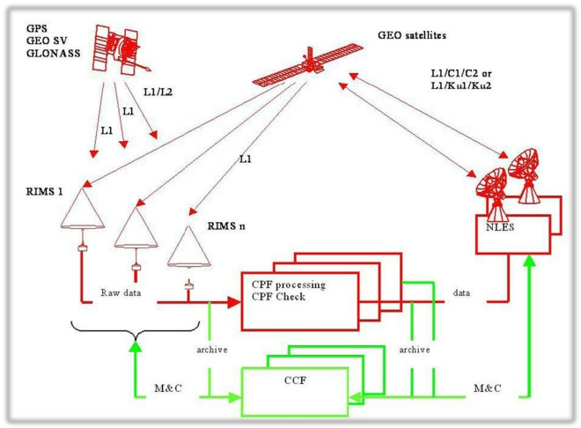

▪The EGNOS data flow is separated in two cycles that shall be completed in less than the 6 second timeframe in order to meet the EGNOS time to alarm requirements. These two cycles are:

1. Processing cycle: RIMS A data collection and message generation.

2. Check cycle: RIMS B and C data collection and correction check.

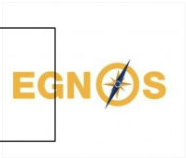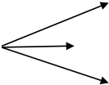

▪ This cycle elaborates the correction and integrity information. The first step is the collection of GNSS/GEO raw data through the channel A of the RIMS stations. These data consists of:

✓Pseudo range measurements (code + phase) on GNSS/GEO satellites signals through the channel A of

the RIMS stations.

✓Universal Time Clock UTCop. The receiver of the RIMS located in Paris (at the LPTF premises) is connected to one of the reference atomic clock “UTCop” used for the coordinated elaboration of UTC. The measurements performed by this RIMS allows, once processed by EGNOS Central Processing Facility (CPF), to measure the time offset between the clock “UTCop” and the EGNOS Network Time (ENT). This information (UTC/ENT offset) is broadcast to the users in a dedicated augmentation message (MT12) allowing users to deduce the UTC time.

▪ These data are sent to the CPF Processing Set in charge of processing the raw data for the generation of corrections and integrity messages. This process takes place in four main steps:

1. Common pre-processing and validation. UDRE estimation

2. Computation of EGNOS augmentation data. corrections for the orbital and clock parameters

3. Internal Check and Quality Estimation. GIVE estimation

4. Processing Output Message Management.

Once the EGNOS messages are generated and checked, they are sent to the NLES. Then the messages are used to modulate a GPS like signal, which is up-linked to EGNOS geostationary satellites and broadcast to users.

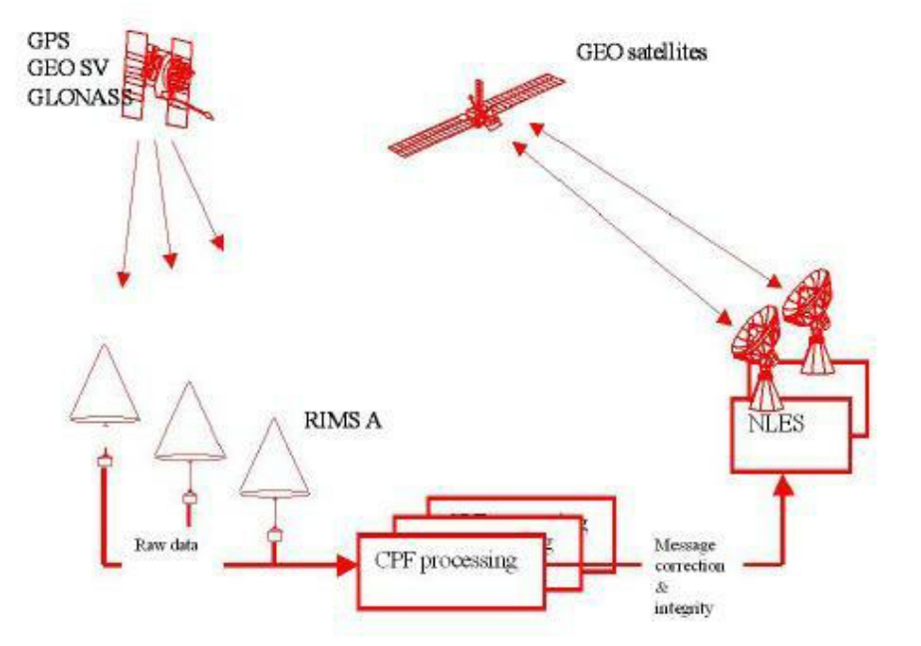

STATISTICAL TEST

▪The CPF Check Set receives GNSS/GEO raw data collected by RIMS stations' channels B and C. The CPF Check Set's job is to check the user's positional integrity independently of the CPF Processing Set and, as a result, to check the validity of the messages generated by the CPF Processing Set before and after they are broadcast to users.

▪Statistical tests are used to verify the accuracy of the adjustments and the residual

errors that result from them.

UERE (User Equivalent Range Error) UDRE (User Differential Range Error) GIVE

GIVD (Grid Ionospheric Vertical Delay)

The CPF Check Set computes correction and residual error, which are then compared to the corresponding values computed by the CPF Processing Set and already broadcast to users.

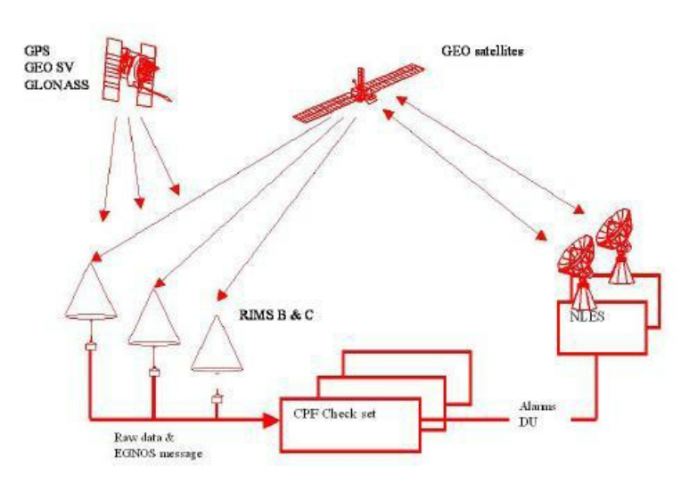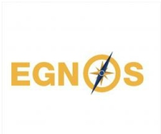

▪ The Central Control Facility is at the center of the non-critical data flow (CCF). The CCF sends and receives data from all ground segment sub-systems. Monitoring and Control data, as well as EGNOS data destined for the archive, are included.

✓RIMS (Ranging Integrity Monitoring Station)

The RIMS sends only raw data streams to the CCF in addition to the generic interface data. These streams of data are received by the communication handler, time tagged and stored into the CCF archive and used by the Mission Monitoring Function.

✓CPF (Central Processing Facility)

This subsystem provides the CCF with RIMS status information produced from CPF computations and a subset of the elaborated data, in addition to the general interface data (residual errors, ephemeris).

✓NLES (Navigation Land Earth Stations)

As the RIMS sub-system, the NLES sends only raw data streams to the CCF in addition to the generic interface data. As the RIMS data streams, these data are time tagged and stored into the CCF archive. transmit the EGNOS message received from the central processing facility to the GEO satellites for broadcasting to users and to ensure the synchronisation with the GPS signal.

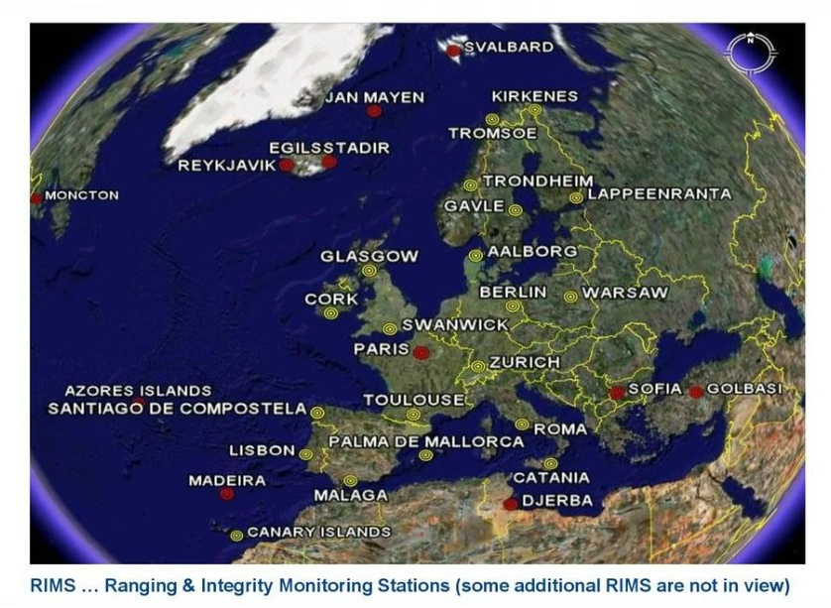

▪The EGNOS system also contains various ground support facilities, such as the Performance Assessment and Checkout Facility (PACF) and the Application Specific Qualification Facility (ASQF), which are administered by the EGNOS Service Provider and undertake system operations planning and performance assessment (ESSP).

✓PACF

It supports EGNOS management in areas such as performance analysis, troubleshooting, operational processes, upgrade specification and validation, and maintenance assistance.

✓ASQF

It provides the tools for civil aviation and aeronautical certification agencies to qualify, validate, and certify the many EGNOS applications.

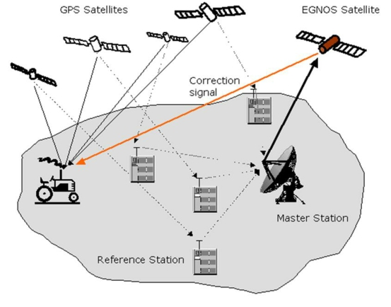

▪The EGNOS user segment is made up of EGNOS receivers that allow users to compute their positions precisely and with integrity. The end user must utilize an EGNOS-compatible receiver to receive EGNOS signals. EGNOS compatible receivers are currently available for the agriculture, aviation, maritime, rail, mapping/surveying, road, and location-based services markets (LBS).

▪An EGNOS receiver is similar to a GNSS receiver, but it includes unique software that allows it to lock onto the EGNOS satellites' code and apply EGNOS corrections to GNSS signals.

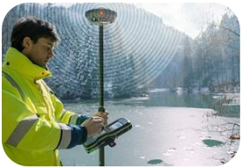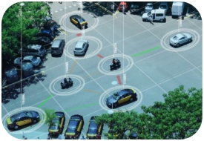

Aviation

Rail

Mapping and Surveying

Timing and Synchronisation

Agriculture

Maritime

Road

Location-based Service

(LBS)

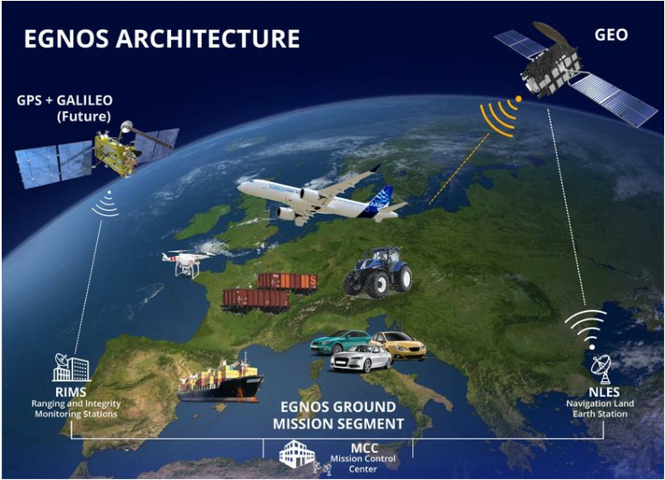

European Geostationary Navigation Overlay Service (EGNOS) improves the accuracy and reliability of GNSS positioning information, and provides a

crucial integrity message regarding the continuity and availability of the signal.

Because of this accuracy and reliability, EGNOS has proven necessary with a variety of applications in a large number of different industries.

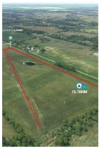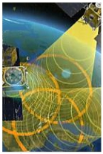

Air traffic over Europe and

congestion at airports in Europe are increasing. This growth in air traffic means that airports must be always easily accessible for succesful transport. For this reason, a satellite navigation system that gives more accurate results should be used.

Providing precisely accurate position coordinates to airborne vehicles both vertically and horizontally.

Pilots can make safer landings in foggy and low cloudy weather.

The error margin is close to 0 since the position verification of air, sea and land vehicles using EGNOS between satellite and land is done at the same time.

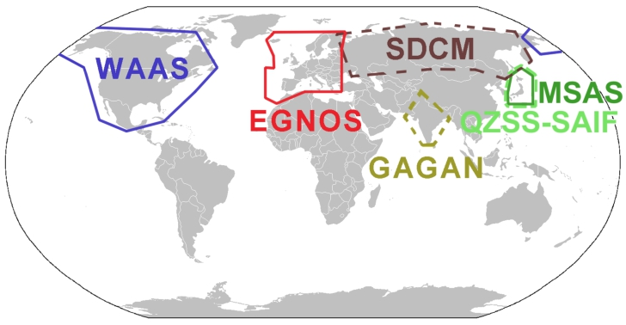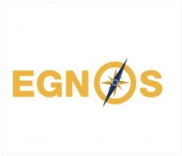

Aviation is the key market segment for European GNSS. Originally EGNOS was designed for aviation. In short, EGNOS has revolutionized the way flying. It has given greater access to smaller airports, increased security and made works easier across Europe.

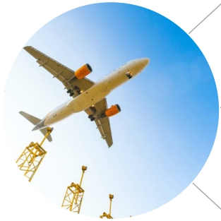

EGNOS can be considered in terms of various benefits and features in the aviation.

• Both a vertical and

horizontal guidance

Safety

• Increasing situational awareness and reducing workload

Cost

Eefficiency

and the

Environment

• Reduced fuel consumption

and CO2 emissions

• A reduction in airport user

fees

Accessibili

ty

• LPV-200

• Even small to medium airports and helipads are accessible in bad weather

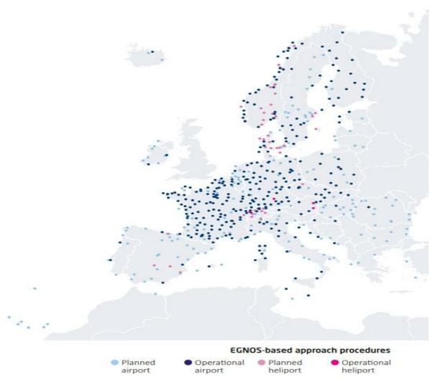

High Precision, Low Investment !

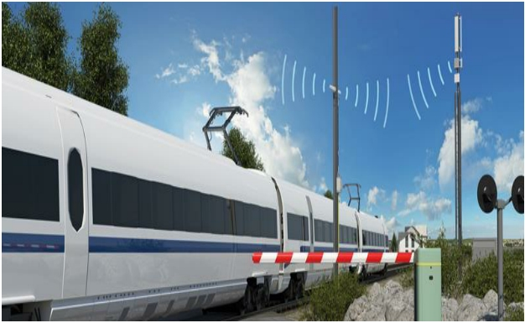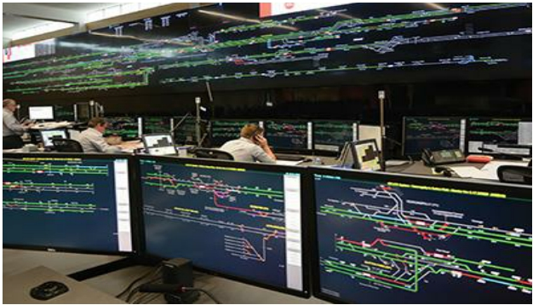

By providing integrity information and improving positioning accuracy and, EGNOS makes it possible to determine train locations while reducing the dependence on expensive trackside infrastructure.

This technology helps decrease costs and increase the efficiency of railway signaling.



As a result of the shift towards a GNSS-based European Train Control System (ETCS), rail will benefit from improved safety and lower operational costs, and all of Europe will enjoy safer rail journeys on regional and low-density lines, with reduced pollution and more precise information services for rail customers.

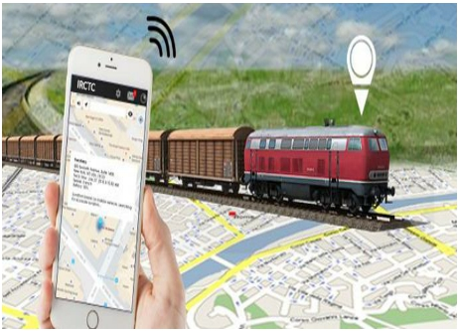

Increased Safety, Lower Costs !



Less

insfructure

Lower investment

and operational costs

Increased safety

Enhanced

Accuracy

Less

Pollution

More precise

passenger

informations services

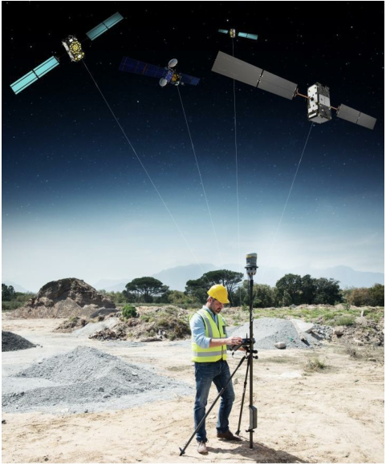

As an effective tool for mapping and GIS applications, Navigation Satellite Systems (GNSS) are

widely used by utility companies and organizations.

In small and medium

municipalities, forestry and park management and infrastructures (e.g. electricity power lines) meter- level accuracy is sufficient.

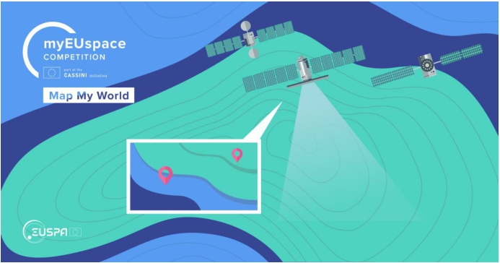

At this point, EGNOS provides free service by increasing the GNSS signals that provide sub-meter sensitivity over Europe.

Also EGNOS is easy to use and it eliminates the need for complex and costly equipment and software solutions of augmentation service providers. EGNOS provides added value by enhancing GNSS positioning, it is free of charge, and most of the devices used for mapping are EGNOS-ready.

High Accuracy,Widely Available!

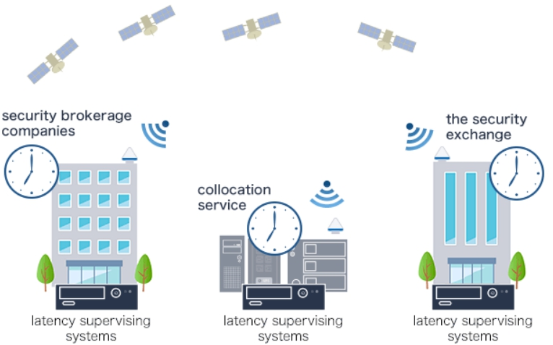

GNSS can be used to provide both timing and synchronisation. GNSS provides direct and

accurate access to Coordinated Universal Time (UTC). On the other hand, synchronisation

between receivers at different locations can be established and maintained using GNSS

reference time.



Worldwide computer and telecommunications networks need highly accurate clock references. The EGNOS system has been providing its own time service known as the EGNOS Network Time (ENT) since March 2011.

The EGNOS time is continuously cross-checked with UTC and the offset is transmitted to the user through the EGNOS navigation message (MT12). EGNOS time information can be obtained from GEO satellites or via the EDAS service, which allows users to access EGNOS data online in real time. EGNOS therefore offers a stable time service that is properly synchronised to UTC across all application domains.

As a result, many Telecom and Energy networks and financial institutions use EGNOS for synchronization.

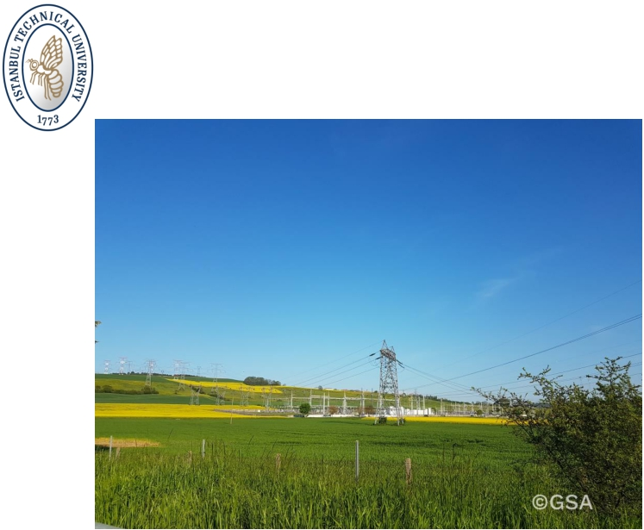

High Accuracy, High Reliability, High Resilience !

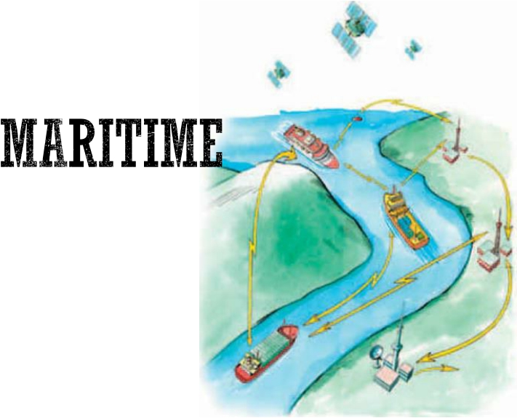

▪European GNSS, specifically EGNOS, makes a significant contribution to the marine industry. All passenger and freight ships with a gross tonnage more than 500 gross tons are controlled and heavily rely on GNSS for navigation. Furthermore, GNSS systems for maritime navigation are widely used on commercial and leisure vessels worldwide, as well as in high-traffic locations. In addition, GNSS is utilized to assure safe navigation on inland waterways (rivers, canals, lakes and estuaries).

▪EGNOS improves marine navigation , from fisheries to oil and gas exploration and enables efficient multimodal transport. They are being used in every phase of marine navigation: ocean, coastal, port approach and maneuvers, under all weather conditions and provides continuous steady real time corrections regardless the distance off the RIMS.

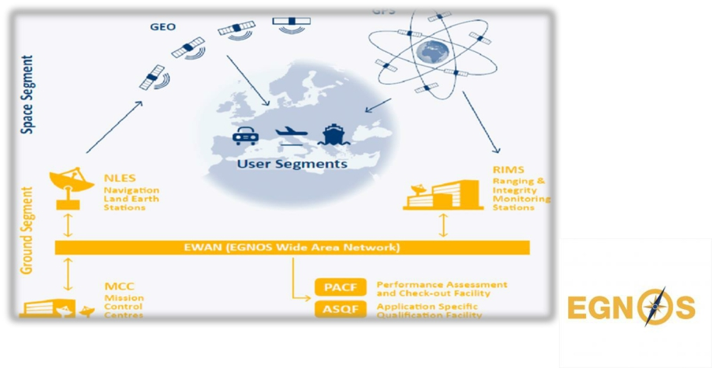

▪EGNOS conformance with International Maritime Organization (IMO) criteria such as accuracy requirements for coastal navigation and horizontal alert limit requirements for navigation zones beyond ports was proved in trials undertaken by the European Commission.

▪EGNOS advantages are also used in Automatic Identification System search and rescue transponder (AIS SART) beacons, where greater location precision and reliability can have a significant influence on search and rescue operations. In severe conditions, EGNOS connections can also be sent via AIS, resulting to increased safety and societal advantages.

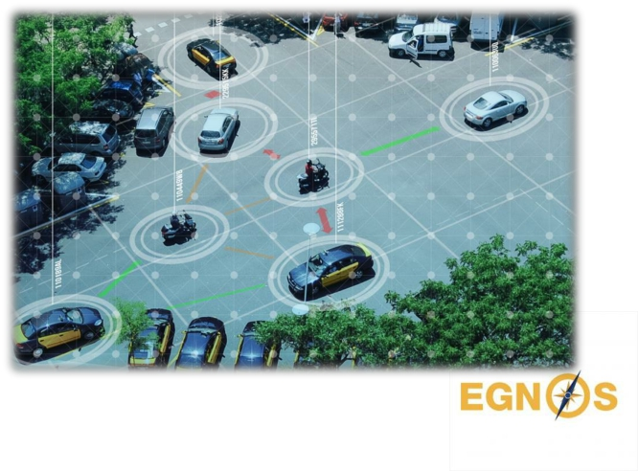

▪European GNSS, including EGNOS, is making everyone's life on the road easier by significantly reducing congestion and, as a result, CO2 emissions, as well as increasing road transportation efficiency through navigation, fleet management opportunities, and satellite road traffic monitoring.

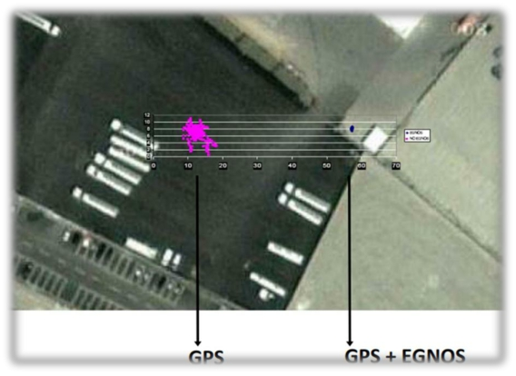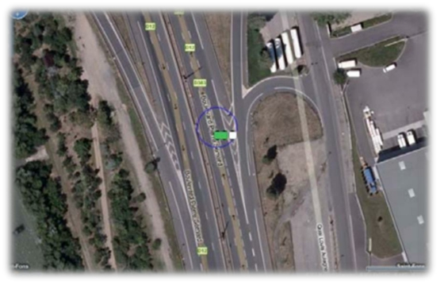

▪Advancements in satellite-based positioning are contributing to the development of better transport services and new applications for safe transport and smart mobility. Smart mobility applications improve the efficiency, effecitiveness and comfort of road transport through: navigation, fleet management, road traffic monitoring. In addition, safety-critical applications leverage precise, reliable and secure positioning in situations posing potential harm to humans or damage to a system/environment. For example, advanced driver assistance and dangerous goods tracking Systems.

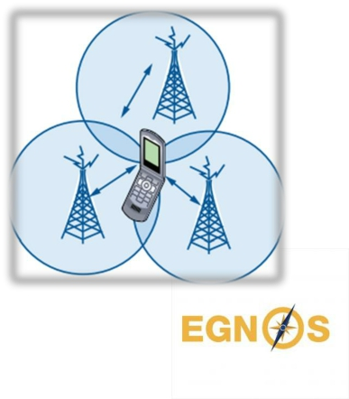

▪EGNOS increases GNSS signal accuracy by decreasing the negative impact of the ionosphere on calculated position. As a result, consumer apps that rely on more precise location information benefit from it, particularly in remote places where network-based solutions are less efficient.

▪Almost 3 billion mobile applications in use today rely on location information. Several types of devices, mostly smartphones and tablets, but also specialized equipment such as tracking devices, digital cameras, portable computers, and fitness equipment, support European GNSS applications.

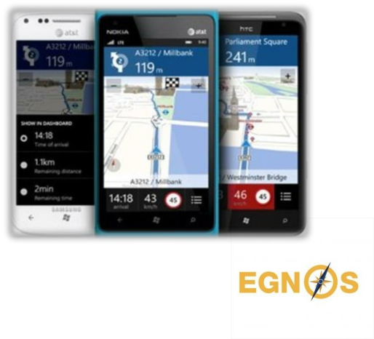

▪Location-Based Services are an excellent match for today's increasingly fast-paced lifestyle, particularly in large cities. They answer to the growing need for mobility in urban environments and faster access to destinations. They also allow for speedier social networking in limited time.

▪Emergency and public services are other segments of the market where EGNOS

could be used to develop value-added applications.



▪Precision farming techniques based on EGNOS are used by farmers across Europe

to reduce the use of fertilisers and lower costs whilst benefiting the environment.

▪EGNOS offers an affordable solution for precision agriculture, enabling farmers to optimise yields, increase productivity, reduce driver fatigue and even enabling labours in reduced visibility conditions.

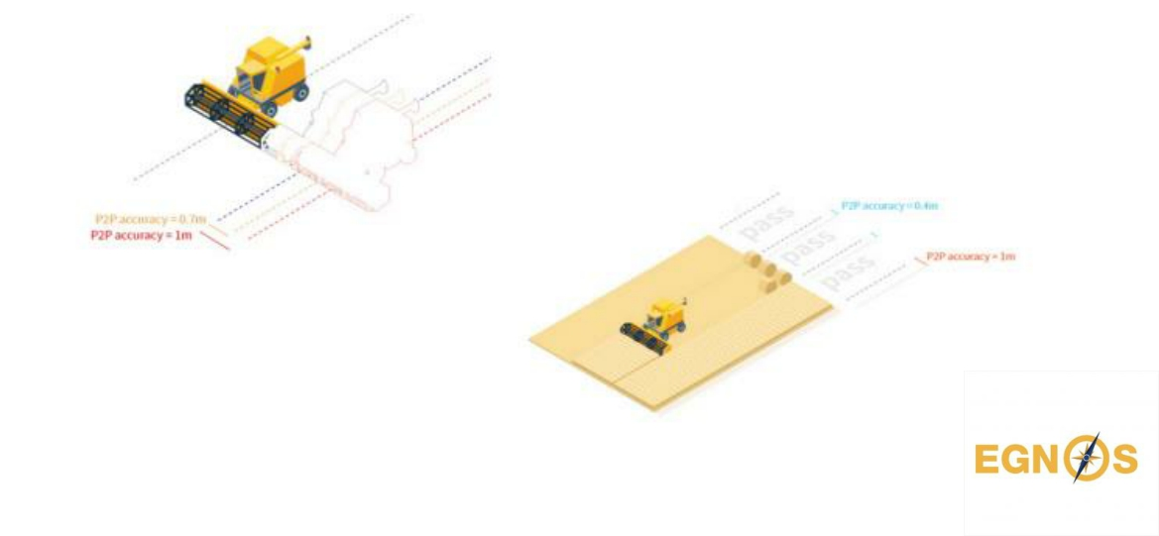

▪EGNOS supports machinery guidance solutions with 10-25 centimetres pass-to- pass accuracy, which is suitable for basic-value crop cultivation (e.g. cereals). It also enables more efficient management of such farming activities as spreading, spraying and harvesting.As a result, the optimised use of seeds, fertilizers and herbicides, as well as a reduction of fuel and driver fatigue, leads to increased productivity. In other words, EGNOS provides advantages to both farmers(higher profits margins) and society (increased food supply and more environmentally friendly agriculture).